Lasagna Soup (Slow Cooker) (Ray)
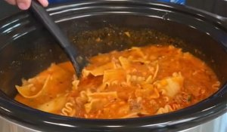

1 jar Marinara Sause (Delallo) Pour into Crockpot
1 lb Ground Beef (Browned)
1 medium Onion (Chopped)
3 tsp Garlic (Chopped)
1 tbsp Italian Seasoning
1 tsp Parsley
2 tsp Red Pepper
Salt & Pepper to taste
2 tbsp Tomato Paste
32 oz Beef (or Chicken) Broth (Swanson)
Mix well, cover and cook on high for 2 hours
Open and crumble 4 strips of Lasagna Noodles on top
½ cup of Heavy Cream
Mix well, cover and cook on high for 1 hour
Serve in bowls with Parmesan Cheese

Bon Appétit

